On the measurement of Hooke’s law in springs

28. August 2024

Sparky Tesla1 and Gravity Falls2 and Quantum Quirk3

1,2,3Department of Physics, Southern Methodist University, Dallas, TX

1 [stesla@smu.edu](mailto:stesla@smu.edu), 2 [gfalls@smu.edu](mailto:2gfalls@smu.edu), 3 [qquirk@smu.edu](mailto:qquirk@smu.edu)

The knowledge of a spring’s elasticity is crucial in many applications. For example, suspension systems of cars rely on coil springs to support the shock absorber. To design these stability and safety systems, the elasticity of the spring must be designed and tested. In this report (module 1 of the 1105 lab) we measured the elasticity of a coil spring based on studying the relation between applied force and displacement. Our measurement demonstrates a linear relation between force and small displacements when forces between and are applied. In this case, the relation is known as Hooke’s law and we find a spring constant of . Our experiment sets the stage to further explore the elasticity properties beyond their linear regime of springs.

1. Introduction

*Introduce the problem. Why do we perform the measurement (motivation) and what do we learn from it; a few sentences. This should be understandable to someone at SMU not taking this course. For example:*

Many materials in nature are elastic, that is if they are stretched or compressed, they return to their original shape when released. This property is called elasticity. Springs are elastic and obey Hooke’s law for small displacements. That is if we apply a force to the end of the spring, its extension (or more generally displacement from the neutral position) is proportional to the force. The constant of proportionality is called the spring constant (expressing rigidity, or stiffness) and is usually represented by the letter . The spring force is a restoring force and its direction is opposite of the spring’s displacement from equilibrium.

Not just coil springs follow Hooke’s law and are springs, but also other objects like a (plastic) ruler that is held fixed at one end and displaced at the other end will follow this law.

1. Theory

*The theoretical background needed for the measurement, including formulas. Usually this would be longer than what follows. For example:*

For small displacements about equilibrium most physical objects behave conservatively, that is the work done in deforming the object is stored as potential energy. Locally in one dimension this potential energy function looks like a parabola centered about the equilibrium position:

Another approach is to express the force as a power series about the equilibrium position . Because we only consider small displacements, we only keep the leading term

1. Measurement setup

*List of equipment and instruments. Describe the setup of the whole measurement procedure. Identify and discuss systematic and statistical uncertainties.*

We make use of a Hooke’s law apparatus shown in fig. 1 to measure the relation between force and spring displacement. The apparatus holds the spring in free fall and comes with an attached ruler to read off the displacement while avoiding parallax errors. The ruler contains a mirror which allows us to align the physical indicator with its reflection, thus assuring we are looking squarely at the scale while recording the extension.

The ruler itself allows for a reading off with a precision of . The ruler can be moved to match zero displacement with the neutral position of the spring without any weights attached.

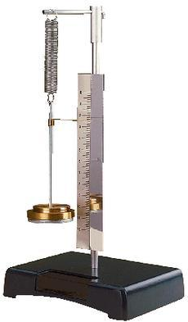

Figure 1: Apparatus to measure Hooke’s law.

We attach one, two, three and four masses with a calibrated weight of 1 N each (figure 2) to the spring, then measure the spring displacement from its neutral position. The uncertainty of the weights is taken as , or about following the manufacturer’s specifications. We have used another calibrated lab scale to confirm that the weight of the masses is indeed within according to the manufacturer’s specs. We can therefore neglect potential systematic uncertainties due to dirt accumulation on the masses (making it heavier) or erosion (making it lighter).

With this data taken, we analyze the relation between force and displacement.

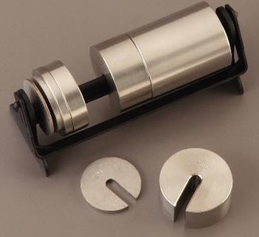

Figure 2: Calibrated slotted mass set.

1. Results and discussion

In figure 3 we show our measured spring displacement as a function of the applied force. We have fitted a linear function with a negligible residual sum-of-squares, indicating linearity in the data. The quoted uncertainties are obtained from the fitting procedure.

In our linear fit we have added a constant term to account for the mass of the spring itself. That is, even at zero displacement there is a force due to the mass of the spring itself.

*(Note that it is in general a difficult but not unsolved problem to consider uncertainties from both the dependent variable, spring displacement, and the independent variable, force. For the purposes of the labs here we will ignore these considerations.)*

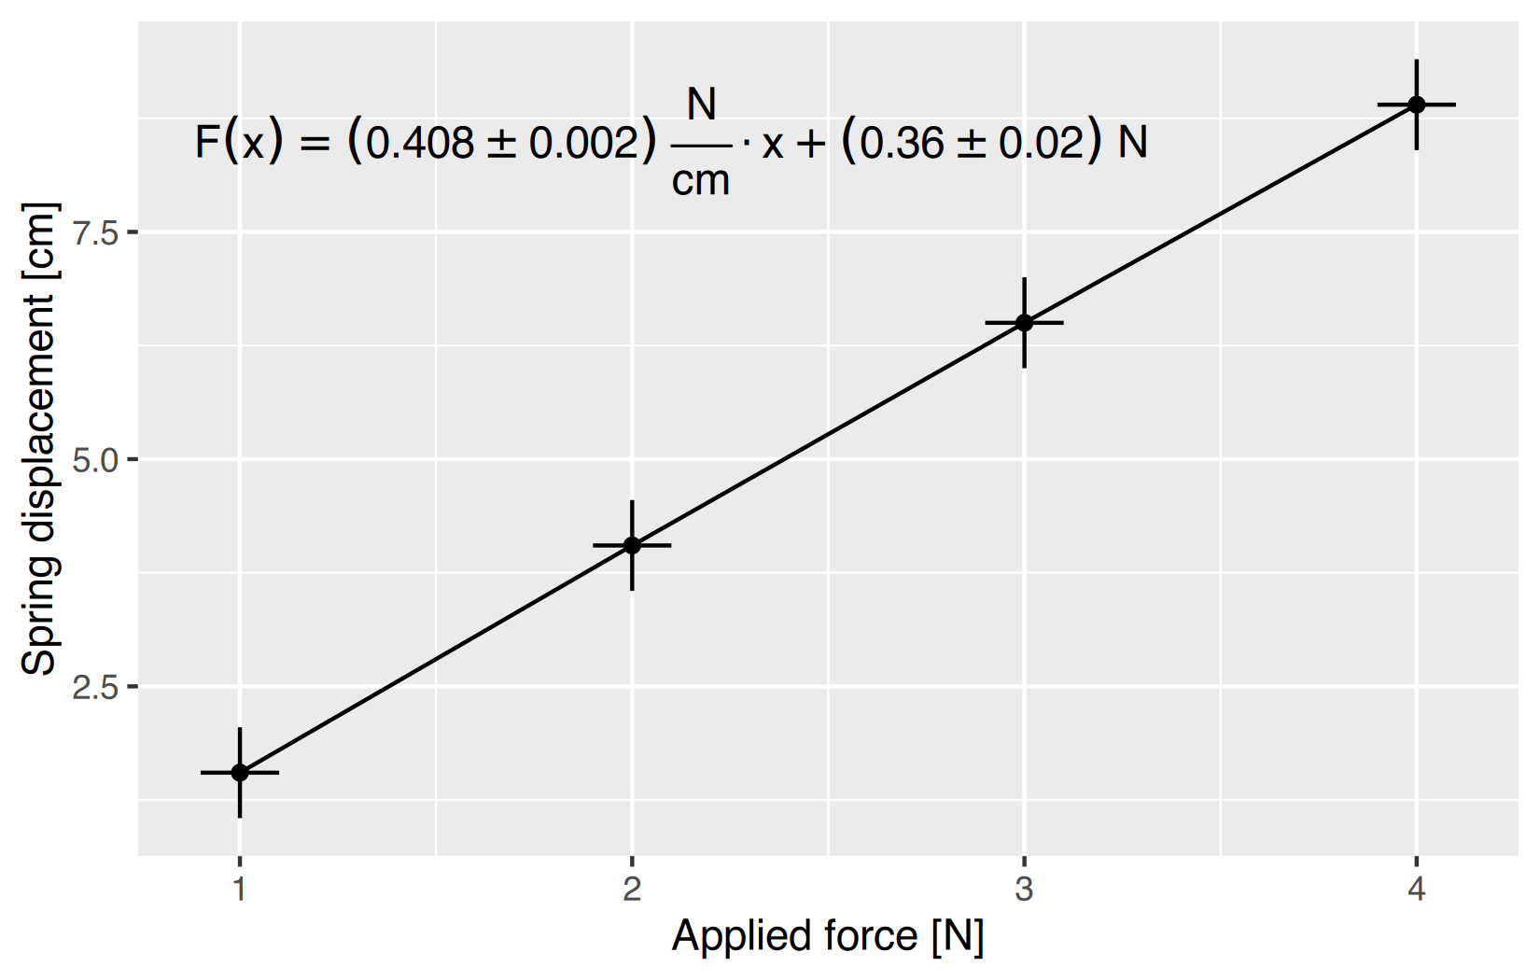Figure 3: Measured spring displacement as a function of the applied force. Error bars are enlarged by a factor of 10 to show their size. The quoted function and the uncertainties are a result of a linear least squares fit.

To put out measurement into a broader context: The coil spring we investigated here can be compared to a car’s coil spring, which has a spring constant at the order of to accommodate for the weight of the car and the right level of displacement. The car would bump up and down if there were no additional shock absorbers that absorb the energy as friction.

1. Conclusions

You could summarize some motivation in one to two sentences, but let’s keep it short here.

In this report we have measured the relation between applied force to a coil spring and its resulting displacement. For our spring we find a linear relation for weights between and . A linear fit results in a spring constant of .

You could further end with an outlook of next steps or open questions.

1. Appendix, raw data

E.g.: We have attached the raw force and displacement data and their uncertainties in the attached “hooke.csv” file